Drawing a Field Plan from FieldMap

Lets try an example for 2019 study DIOP19 at Were

This trial has 28 entries in three reps (84 plots) and according to the FLD_ROW and FLD_COL coordinates imported is laid out in 12 ranges and 7 columns, in a serpentine order. If you lay out the imported plan according to FLD_ROW and FLD_COL you get the following fieldplan of plot numbers:
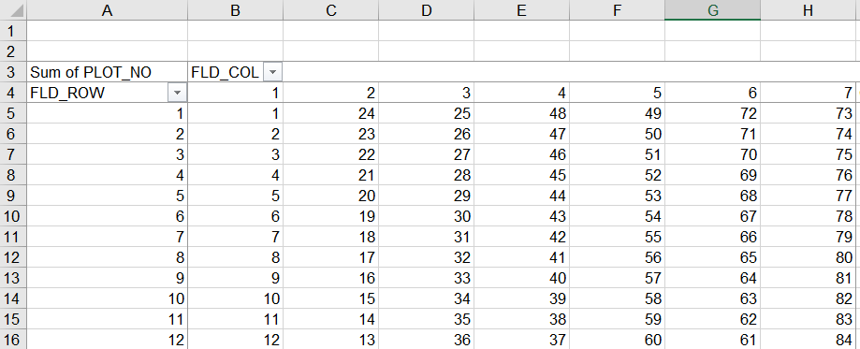

We want to make a BMS Filedmap which matches this lay out.

Open the study and select Actions>Field Map options>Make Fieldmap
Select the trial to be mapped - DIOP19
Enter the Field Location – Werer (BMS should know this already)
Now you have to make a field at Werer and these fields can be re-used cycle after cycle and they may correspond to real fields at the location. I just made Werer1.

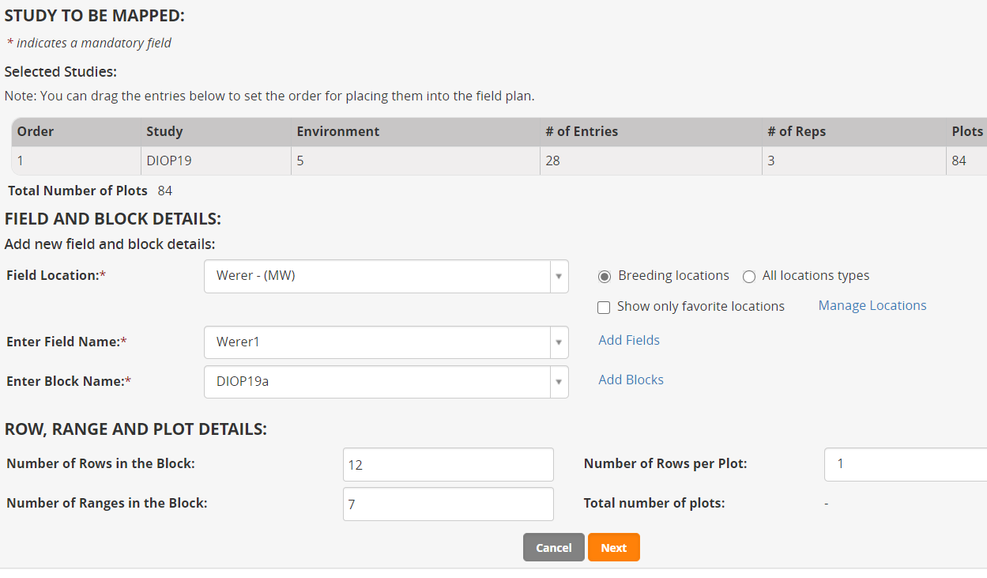
Now you must make a Block. A block is a part of a field for a particular season. They cannot be re-used since they reflect the season. The block will also reflect the planting arrangement ie plant rows per plot and rectangular array of plots. The planting arrangement must be constant over the whole block. You can make another Block in the filed for a different planting arrangement or for the next season which may partially or completely overlap the last season block.

The original idea of the FieldMap was that you could put may studies in the same block and you can still do that, but there is no way to optimize where the studies go, so this feature is not useful. Hence I always make a block for each individual study instance in the field. Hence I make a block which reflects the study as in DIOP19a. (The a is because I took two attempts to get it right, not noticing that the original layout is serpentine).

The ‘Rows’ referred to in the above form are plant rows, not plot rows. So you can enter the number of plant rows across the block and the number of rows per plot. The division gives the number of plots across the block which are referred to as FIELDMAP_COLUMNs. The rows of plots in the block are referred to as FIELDMAP_RANGEs so the product gives you the number of plots in the block. The idea is that the plant rows run along the plot columns and perpendicular to the ranges. This information about direction of plant rows is missing from the imported fieldplan and is perhaps not important, but if we assume there are 12 columns (along which the plant rows run) and 7 ranges then our FIELDMAP_COLUMN is going to be equivalent to the imported FLD_ROW and our FIELDMAP_RANGE is going to be equivalent to the imported FLD_COL. This means the BMS field map will be a transpose of the imported one. If the direction of the plant rows in unimportant I suppose you could specify a block with 7 plots across the block and 12 ranges and the FIELDMAP_COLUMN would map to FLD_COL and FIELDMAP_RANGE would map to FLR_ROW and the plan would not need transposing. However we will continue with the transpose.

Click Next to assign the plots to the block.
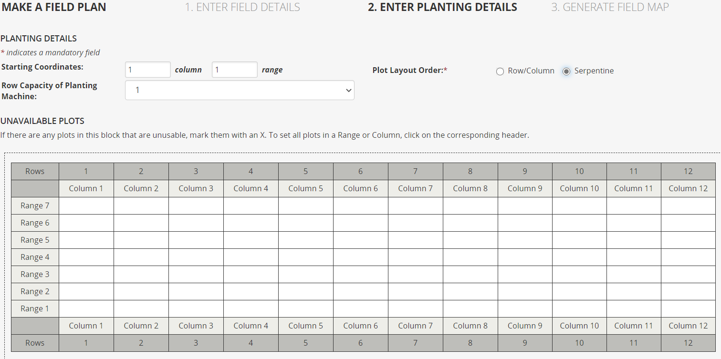
Select Serpentine to match the original layout which was imported into the study.
Click Next to assign the plots:
Then Actions>Export to Excel.
Click Finish to leave the mapping tool.
Also export a Fieldbook for the trial – Actions>Data collection options>Export study book.
Open the FieldMap excel file. Change the font on the map to size 8:
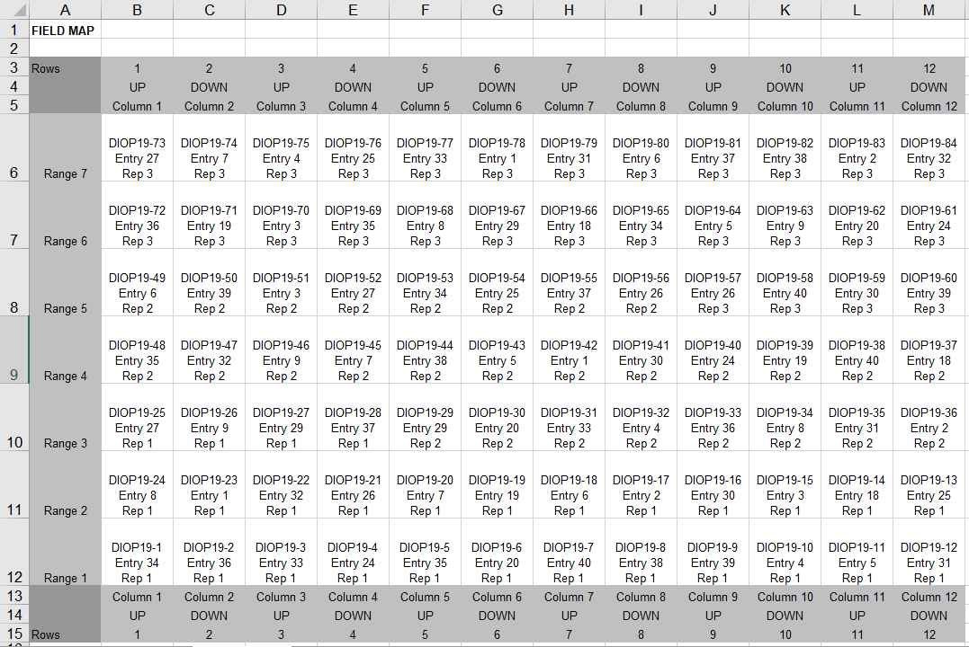
So this is orientated the wrong way compared to the imported lay-out above.
Open the Study book and make a new sheet called FieldMapBMS
Copy the central cells of the design from the fieldmap file (cells A6 to M12)

Paste them with transpose into the FieldMApBMS sheet of the Study book:
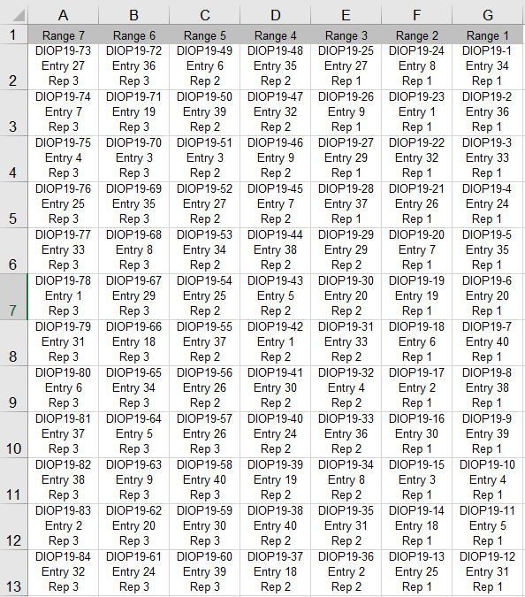
This is still not quite right because you would expect your ranges to be sorted from 1 to 7. So sort them.
Remember we are sorting columns not rows so you have to pick the Left to right option in the sort dialogue box.
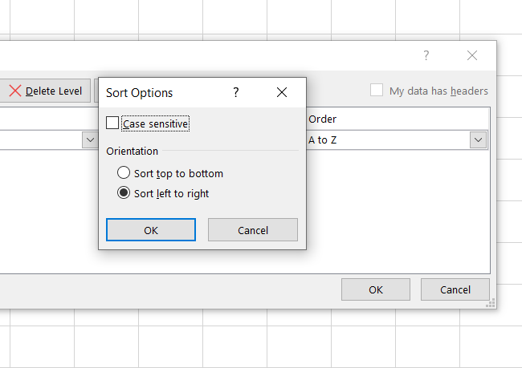
You can then add the margins where the rows correspond to FIELDMAP_COLUMN and the columns correspont to FIELDMAP_RANGE
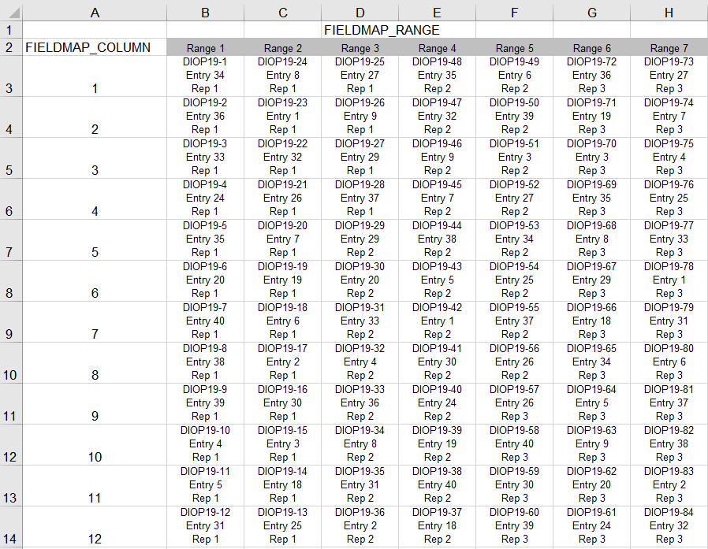
Now if you want just the Plot number and the entry name in your map you can use VLOOKUP excel function to get those. This looks up a plot number:
=CONCAT("Plot ",MID(B3,FIND("-",B3)+1,FIND("Entry",B3,1)-FIND("-",B3)-2))
And this looks up the DESIGNATION from the Observation sheet based on the Entry No in the map:
=VLOOKUP(NUMBERVALUE(MID(B3,FIND("Entry",B3)+6,FIND("Rep",B3,1)-FIND("Entry",B3)-7)),Observation!$B$2:$D$29,3,FALSE)
You can color the reps and the map looks like:
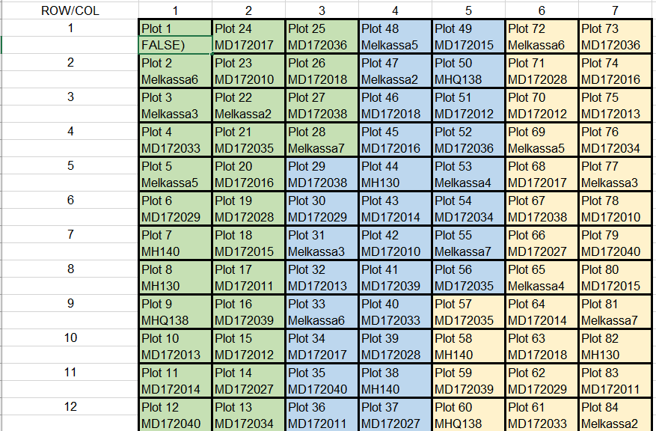
An Alternative strategy is not to use the BMS to make your fieldmap since you have already imported it.
To do this you use a Pivot Table from the Observations sheet of the Study book and save it to a new Sheet. Pivot with FLD_ROW and rows, FLD_COL as columns and PLOT_NO as contents.
Rename the new sheet to FieldPlanImport.
Copy the array of plot numbers from the pivot table and paste them as values in an array below the pivot table:
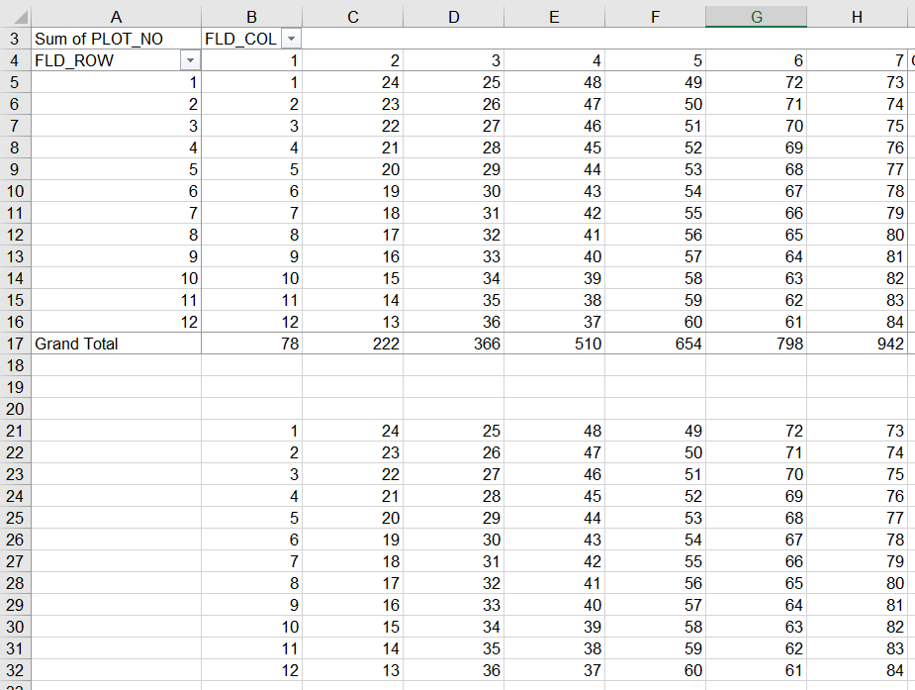

Copy the column of plot numbers from the Observation sheet to column K of the FieldPlanImport sheet. Copy the column of designations from the Observation sheet to column L.
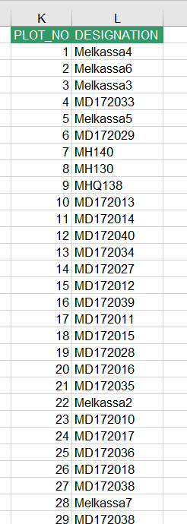
Now copy the PLOT-NOs to a fieldmap area with formula:
=CONCAT("Plot ",TEXT(B21,"0"))
and look up the DESIGNATION of the entry on that plot with formula:
=VLOOKUP(B21,$K$2:$L$85,2,FALSE)
Now format the plan a bit, colour the reps and you have the same as the FieldMap plan:
