How to Connect to BMS using Fieldbook
NOTE: This short tutorial uses the test server in http://18.138.161.89/ibpworkbench/main to show how to connect to the server APIs. For this purpose, we are going to open the “T WHT R19 MUL NIVT-1A” study.
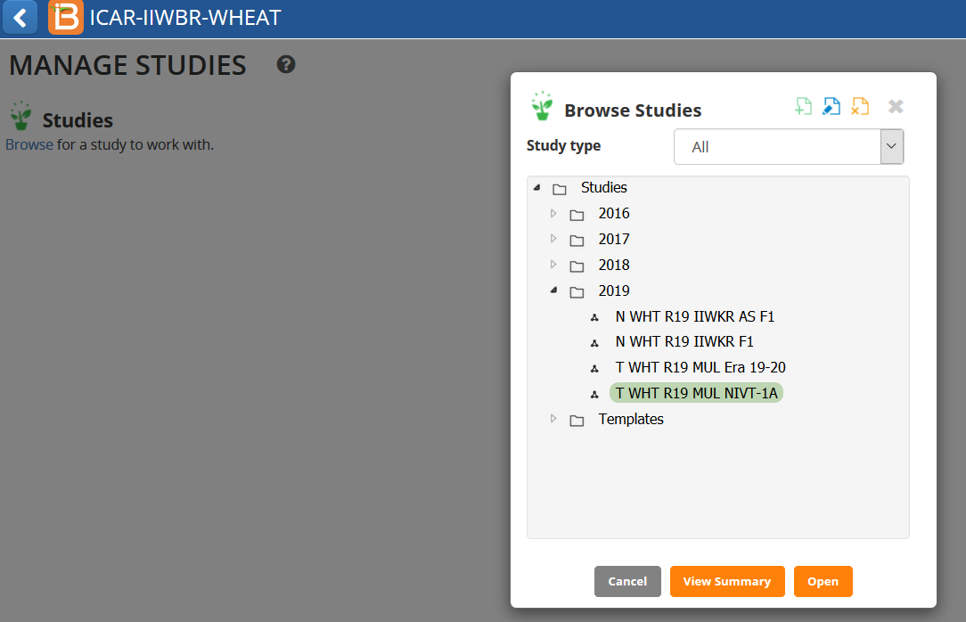

The Observation has Germ_M_pct, Hd_dto_day traits and others. We will use Fieldbook to record values into these two traits.
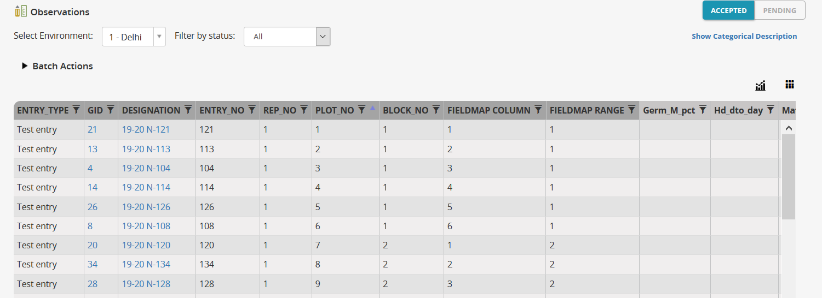
STEPS:
- Download APK 4.2 for Fieldbook from here : https://drive.google.com/file/d/1zvBKxNyqedICkTkFcCfR1ppu61q0wKQr/view?usp=sharing
- Install Fieldbook version 4.2
- Open the Fieldbook Application and click Settings.
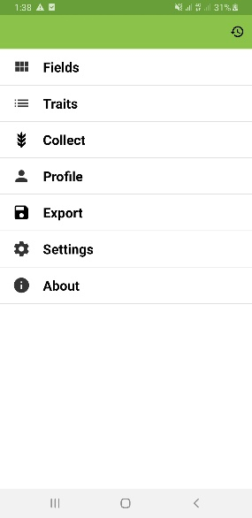
- Select BrAPI
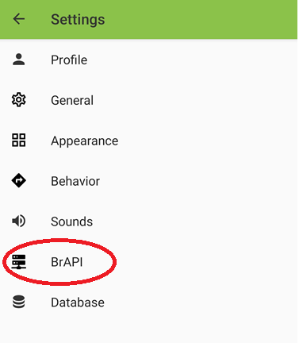

- Select BrAPI Base URL
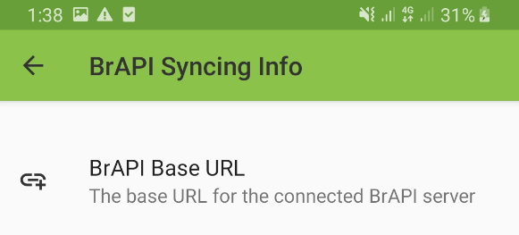

- Enter the BrAPI Base URL. In this tutorial use : http://18.138.161.89/bmsapi/<name_of_crop>. In this example, we are connecting to the wheat crop. Click Save and Authorize.
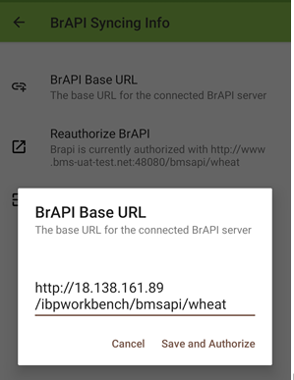
- It will open the Authorization page. Enter the BMS login Name and Password
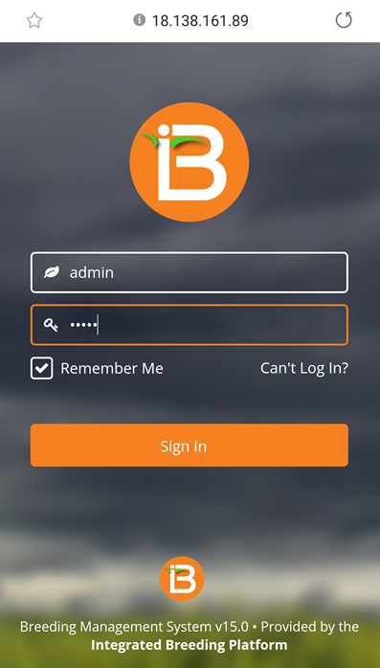

- Click Authorize.

- In the General Settings, set the Default import and export source as BrAPI. If default import or export source is not BrAPI, click Default export Source.
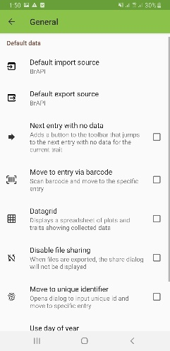
- Select BrAPI
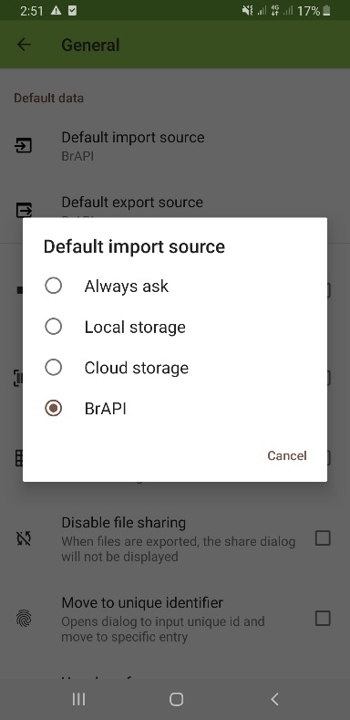
- To get the study instances, go to FIELDS.
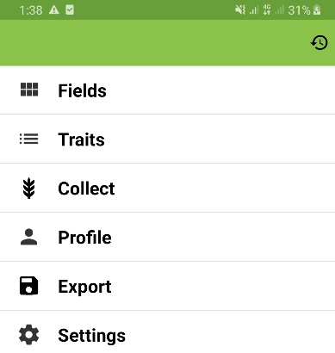
- To add a new field or environment instance into Fieldbook. Click on the +

- Select the field for measurement. Choose T WHT R19 MUL NIVT-1A-Environment Number 1. This is the first instance of the Study. To go back to the main choices, click on the arrow on the left.

- Click Ok . Click Save Field.
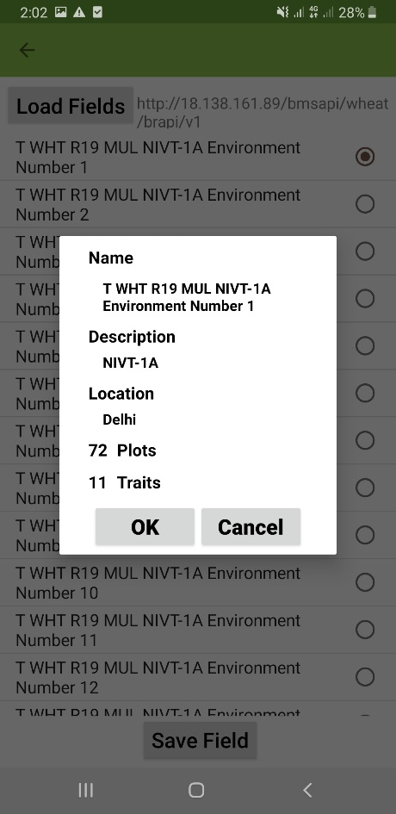

- Click on Traits to select the traits that will be measured.
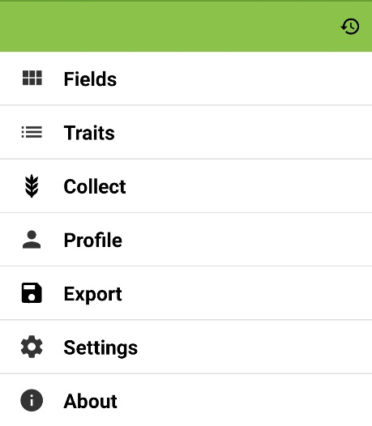
- Please take note that traits from other fields will be in the list of traits.
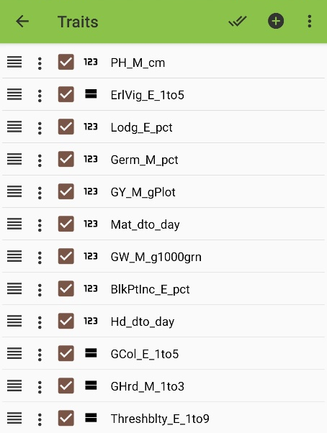

- Select the Traits that will be measured.

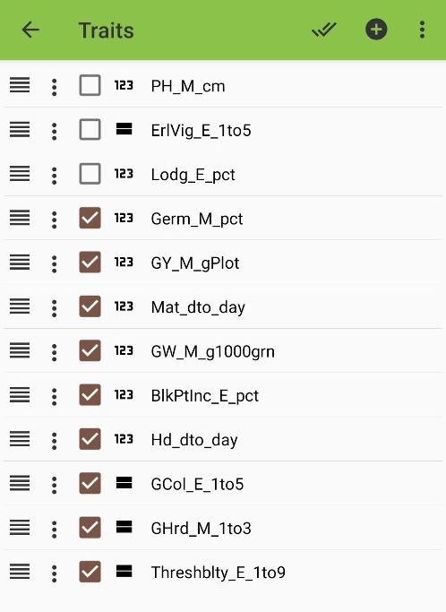

- To start entering observed values, click “COLLECT”.
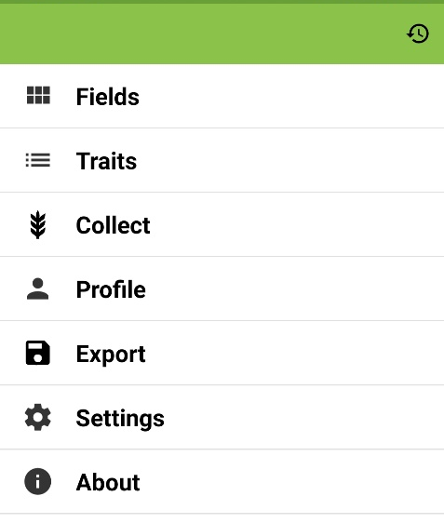
- To move to different traits, click on the green arrows.
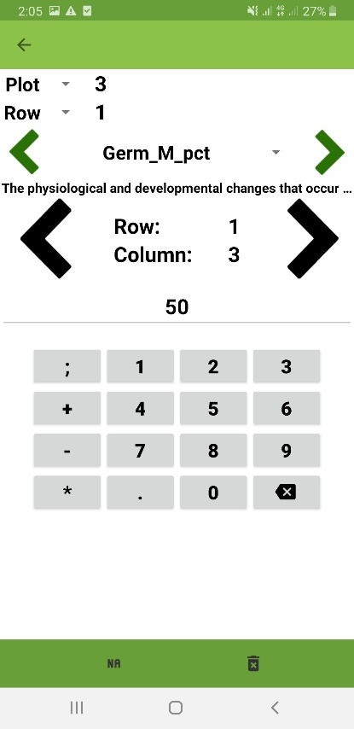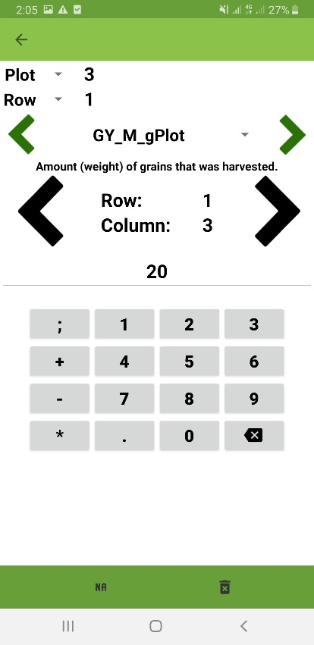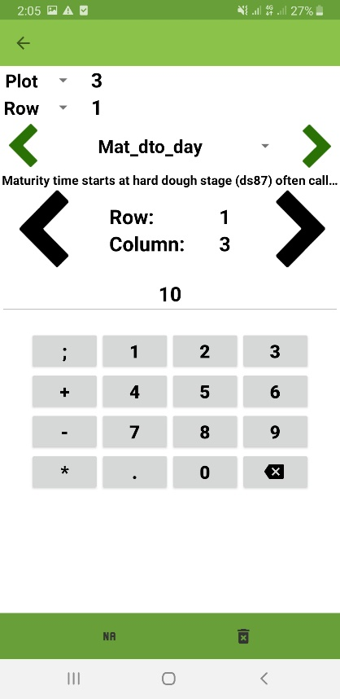

- To move to different plots, click on the black arrows.
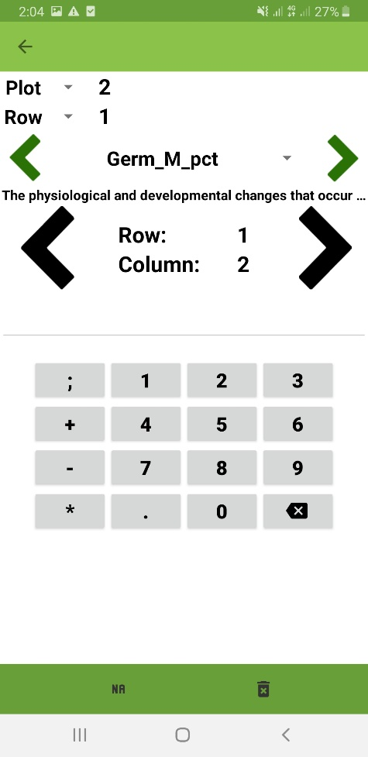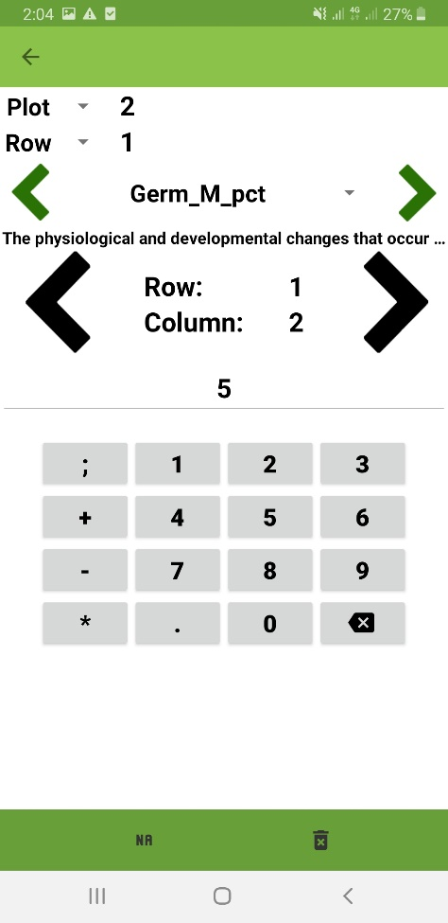

- To export the values to the server, click Export.
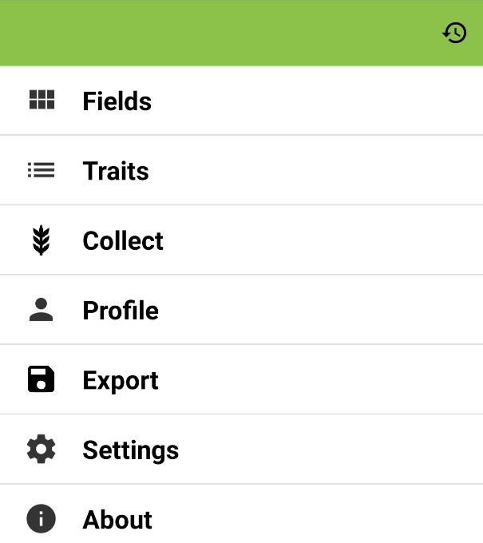

- In the export page, you should see the number of new or modified observations. Click Export.
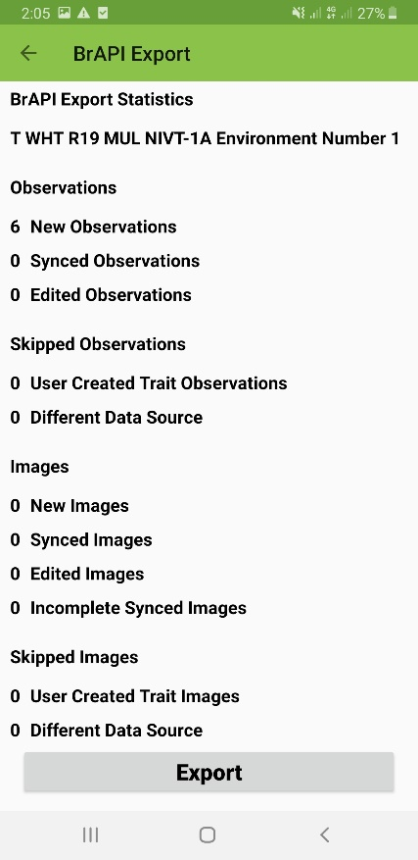
- “BrAPI Export Successful” message shows up if the export is successful.
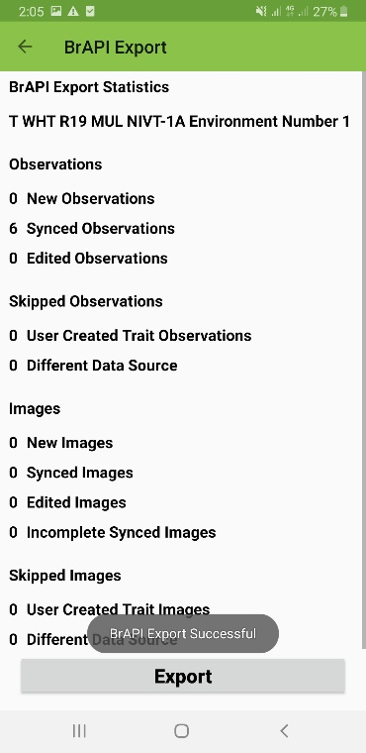
- Check the observation measurement in the server. After Exporting, observation tab should now reflect the values entered using Fieldbook.

